Live Like You Were Dying

Live Like You Were Dying

Tim McGraw

 | D/F# | G | Cmaj9
 | He said I was i | n my early forties with a | lot of life before me

 | Em7 | D | C(9
and a | moment came that stopp | ed me on a di | me

 | G | Cmaj9
I spent m | ost of the next days | looking at the x-rays

 | Em7 | D | C(9
 | and talking 'bout the o | ptions and t | alkin' 'bout sweet time

Em Eb(sharp)

I asked him when it sank in that this might really be the real end

 | G/D | Cmaj9
How's it | hit 'cha when you get that kind of news, m | an what'cha do

CHORUS:

 | G
(and he said) I went s | ky diving

 | Cmaj9
I went | rocky mountain climbing

 | Em7 | D | C(9
I went | two point seven sec | onds on a bull | named Fu Man Chu

 | G | B7 | Em | D
 | And I loved deeper | and I spoke sweeter a | nd I gave f | orgiveness id been

 | C(9 | Dsus
deny | ing and he said some day I hope you get the chanc | e to live like you

 | G | Em7 | C(9
were d | ying

 | Dsus | G | Cmaj9
 | He said I was fi | nally the husband that m | ost the time I wasn't

 | Em7 | D
And I b | ecame a friend a fri | end would like to have

 | G | Cmaj9
And all | a sudden going fishin' wasn't | such an imposition

 | Em7 | D | C(9
 | And I went three times that y | ear I l | ost my dad

Em
Well I finally read the Good Book

Eb(sharp) G/D

and I took a good long hard look at what id do if I could do it all again

Cmaj9
and then...

 | Cmaj9 | G
 | I went | sky diving

 | Cmaj9
I went | rocky mountain climbing
 | Em7 | D
I went | two point seven se | conds on a bull named Fu Man Chu

 | G | B7 | Em | D
And I l | oved deeper and I s | poke sweeter and I | gave forgive | ness id been

 | C(9
den | ying and he said some day I hope you get the chance

 | Dsus | Em
 | to live like you were dy | ing

Eb(sharp) G/D Cmaj9

Like tomorrow was a gift and you got eternity to think about what you'd do

 | D/C
with it and what did you do w | ith it

 | Cmaj9
what did I d | o with it

What would I do with it

A
Sky diving I went

Dmaj9
Rocky mountain climbing

 | F#m7 | E | D(9
I went | two point seven sec | onds on a b | ull named Fu Man chu

 | A | C#7
And I l | oved deeper and I | spoke sweeter

 | F#m | E
and I | watched an e | agle as it was flying

and he said, someday I hope you get the chance

 | Esus | A
 | to live like you were d | ying

 | D(9 | A
 | to live like you were d | ying (repeat a couple of times and fade)

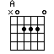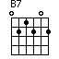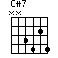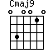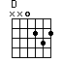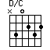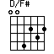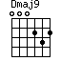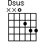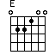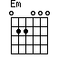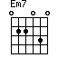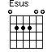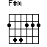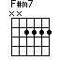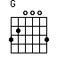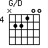
variations - click chord images

